|  |  |
| --- | --- |
| Name | Yunzhe Li 李昀哲 |
| Current Visa Status | F-1 |
| Visa Sponsorship | OPT |
| Minimal Sponsorship Requirement | Unpaid employment. More details on Figure 1. |
| Evidence Needed from Employer | A signed document verifying the hours worked each week. More details on Figure 2. |

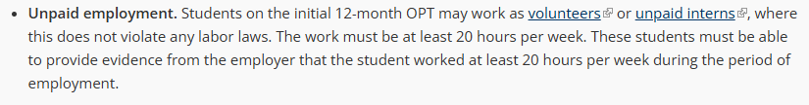

Figure 1. Definition of Unpaid Employment. Source: <https://internationaloffice.berkeley.edu/students/employment/opt>

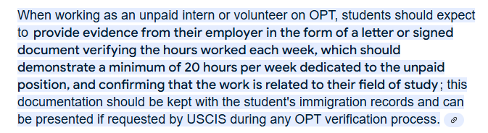

Figure 2. Evidence from employer